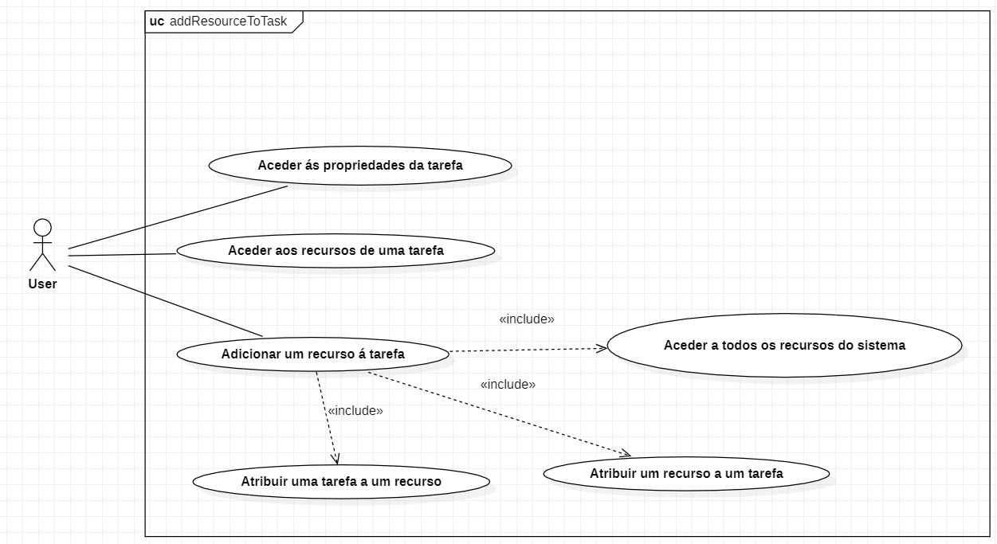**Use Case Guilherme Abrantes (60971)**

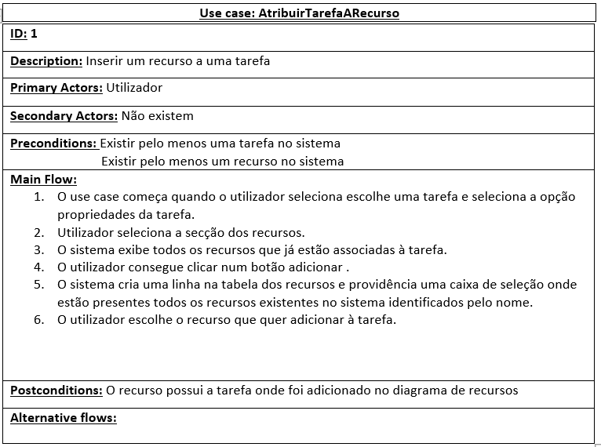

**Use Case Miguel Agostinho (60677)**

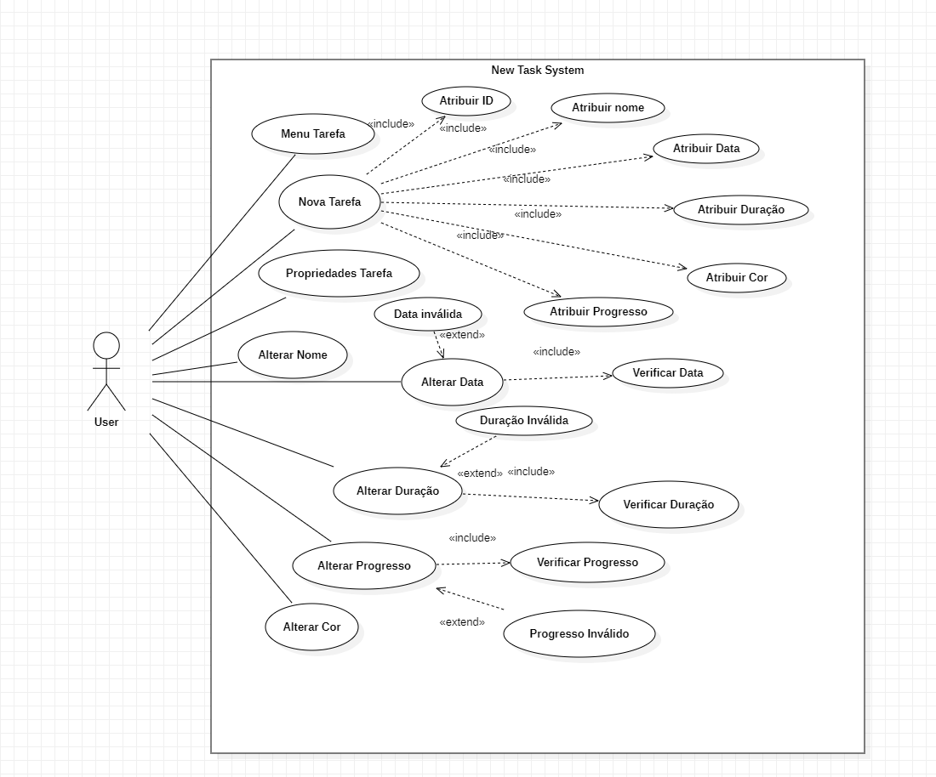

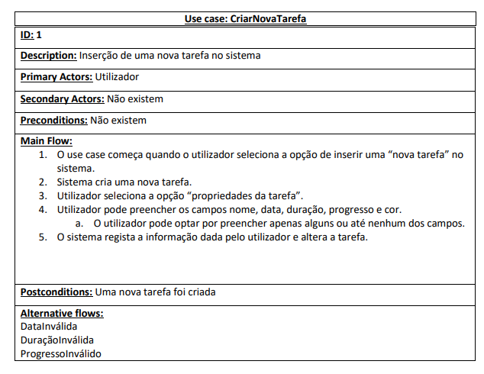

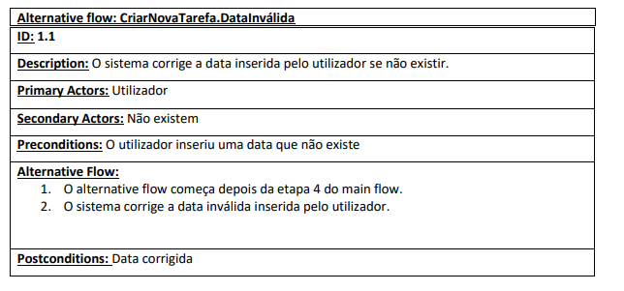

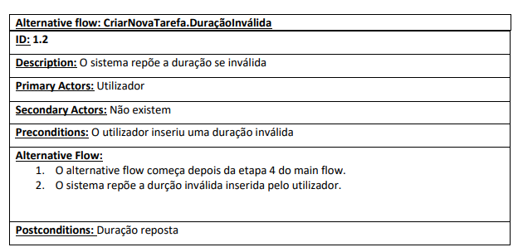

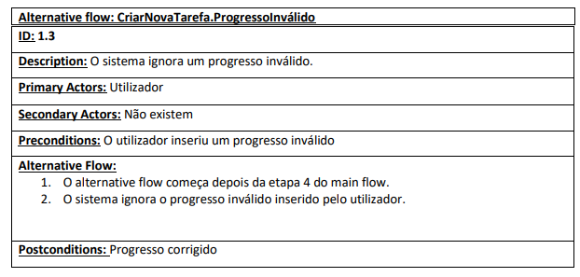

**Use Case Rafael Costa (60441)**

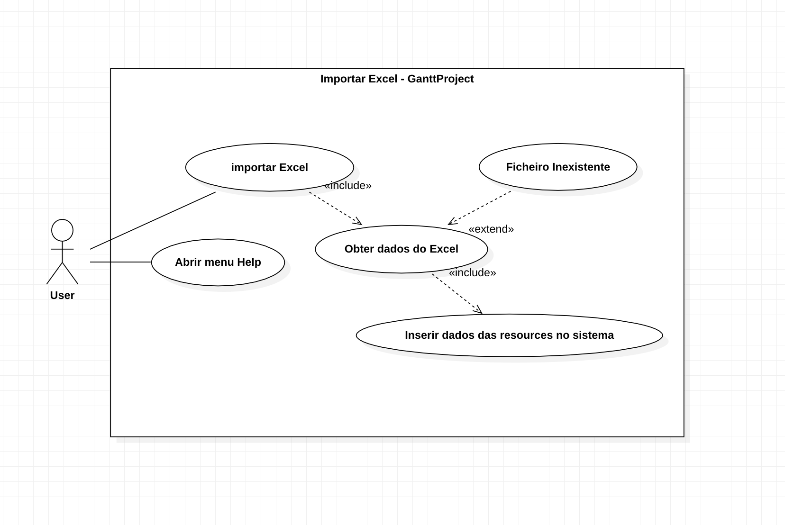

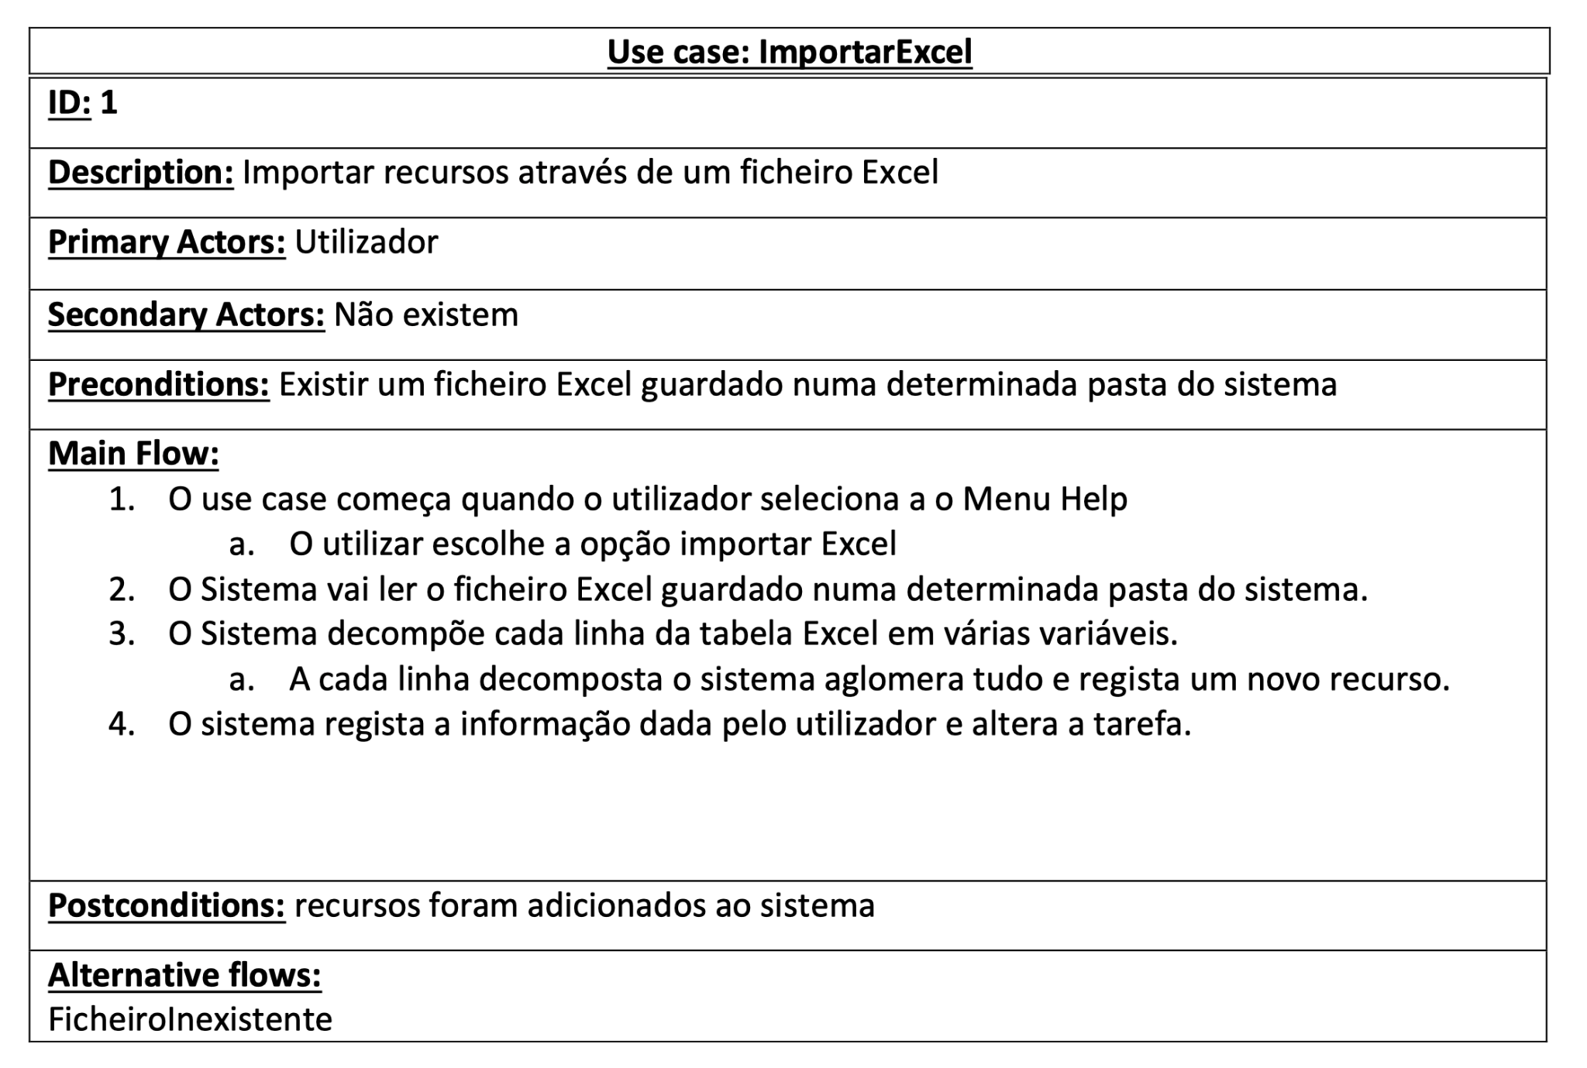

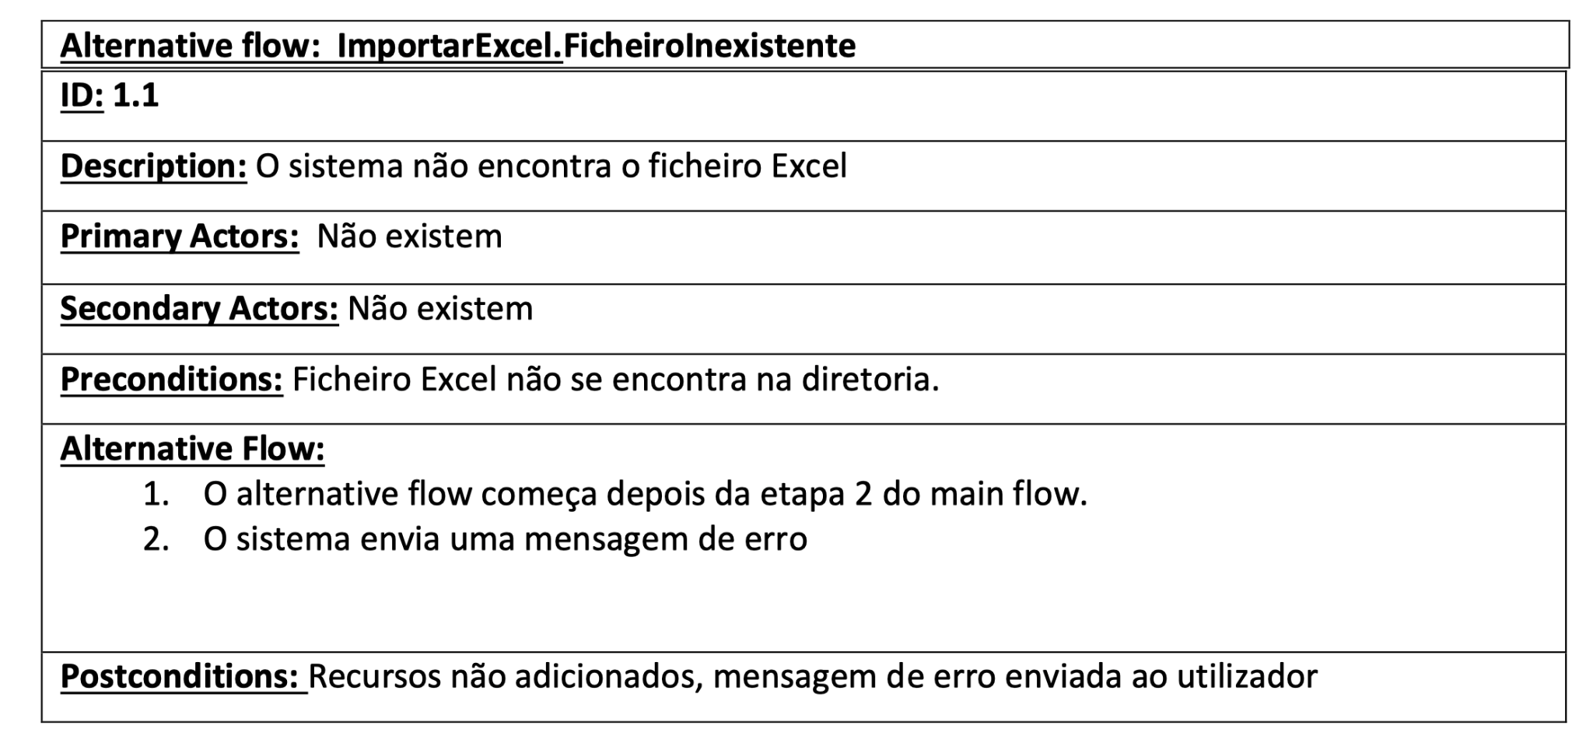

**Use Case Daniel Eugénio (59797)**

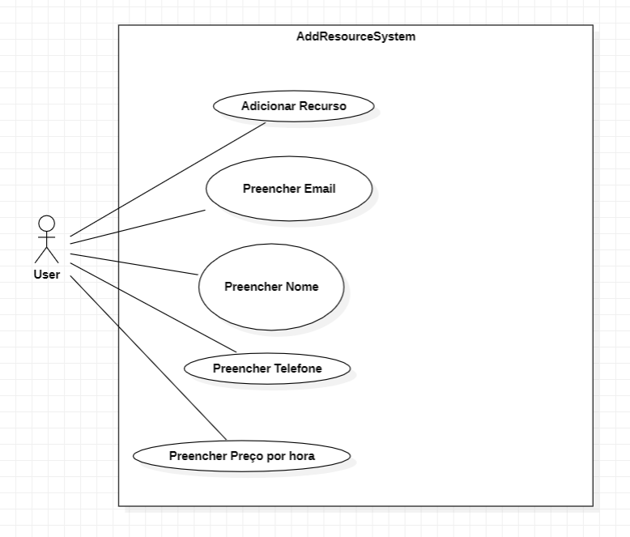

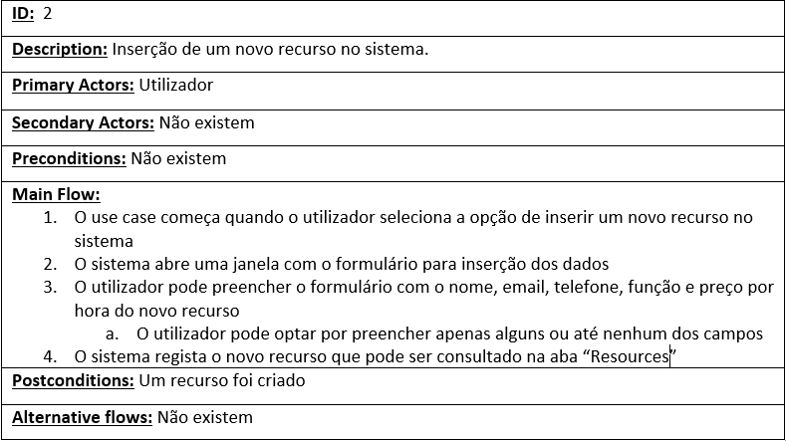

**Use Case Francisco Silveira (60816)**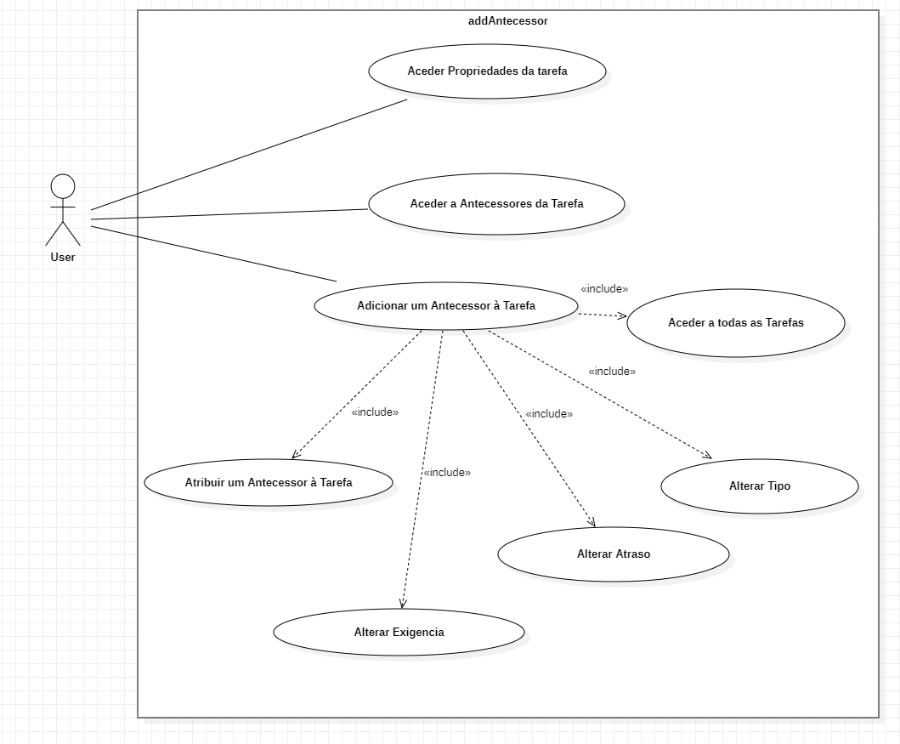

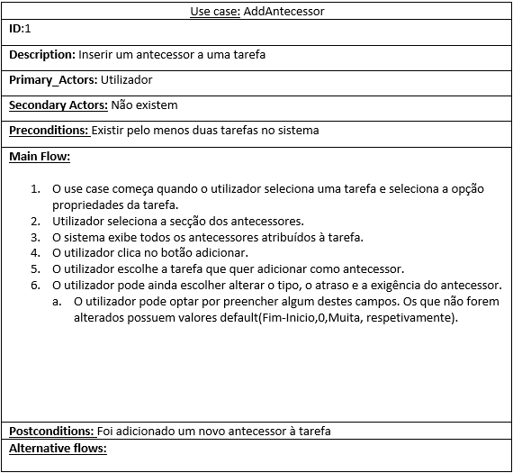

**\**

**User Stories Daniel Eugénio (59797)**

* As a user I want to be able to view all the resources in the system so that I don't add the same person twice.
* As a user I want to be able to insert new columns to the resources so that I can complete their information as I see fit.

**User Stories Rafael Costa (60441)**

* As a user I want to be able to import resources to the system using excel so that It will not be necessary to add a lots of resources by hand
* As a user I want to save the project file so that I can send to my co-workers.

**User Stories Guilherme Abrantes (60971)**

* As a user I want to see what tasks each resource has so I don't waste time going through every task to check.
* As a user I want to zoom out my calendar so that I don't waste time scrolling right to plan my work.

**User Stories Miguel Agostinho (60677)**

* As a user I want to add tasks so that I can manage my project.
* As a user I want to highlight completed tasks so that I can see these tasks better.

**User Stories Francisco Silveira (60816)**

* As a user I want to add predecessors to my tasks so that I can organize which tasks to do first.
* As a user I want to add a resource's days off so you can organize the project without delay.